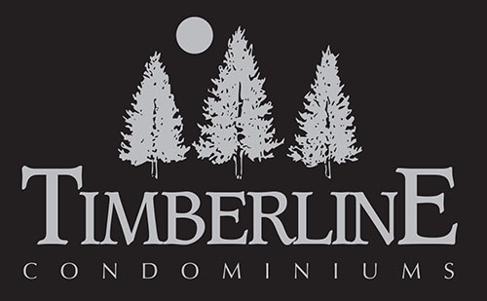
Statement of Purpose

The Timberline Condominiums is a deluxe condominium hotel located in a mountain destination that provides an excellent vacation experience to domestic and international guests as well as to their homeowners.
Our Vision
For our Guests:
By providing memorable experiences that exceed our guests’ expectations, through great customer service, location, deluxe condo’s and overall property amenities. The staff and owners contribute to our guests’ enjoyment, memories, through interactions with others. Results are shown by repeat visits, personal referrals and references to new guests, thus providing business growth for the Timberline.

For our Employee Family:
By providing caring and effective management, we develop employees’ job skills and confidence, which in turn provides job satisfaction, personal development, opportunities for advancement, and a greater standard of living for each individual and their family.

For the Management Company:
By growing the short-term rental program with improving and maintaining high quality unit décor, comfort, and functionality, owners contribute to our guests’ memorable experiences and satisfaction and enable our business success. Offer the expected property amenities and services for a deluxe property within the industry standards.

For our Owners:
By providing excellent hotel services and property management, the revenue, equity and unit values will grow for the owners. Owners to be able to enjoy and relax during their stays at the Timberline.

For our Community:
By becoming involved and working closely with local businesses and communities throughout the Roaring Fork Valley, we work together to promote and enhance all there is to do and offer for guests and owners.

